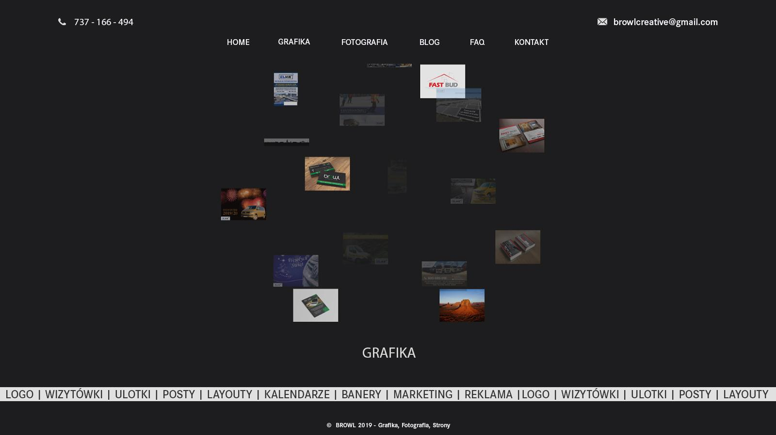

**GRAFIKA**

-------------------------------------------------------------------------------------------------------------------------------  
Tel. 737 166 494 @ browlcreative@gmail.com[l](mailto:kontakt@browl.pl)

-------------------------------------------------------------------------------------------------------------------------------

MENU: Home | Grafika | Fotografia | Blog | FAQ | Kontakt

-------------------------------------------------------------------------------------------------------------------------------

kula

-------------------------------------------------------------------------------------------------------------------------------

GRAFIKA

-------------------------------------------------------------------------------------------------------------------------------

LOGO | WIZYTÓWKI | ULOTKI | POSTY | LAYOUTY | KALENDARZE | BANERY | MARKETING | REKLAMA |

-------------------------------------------------------------------------------------------------------------------------------

© BROWL 2019 - Grafika, Fotografia, Strony www